TIP: To quickly return to your search results, right-click the link to open in a new tab. When finished, simply close the window and return to your teaching schedule.

Use this resource to view My Teaching Schedule. The View My Teaching Schedule displays your assigned course sections, student roster, and grade assignments.

Instructions
- Log into Workday and click “Teaching”.
- Click “View Teaching Schedule”.
- Click the Academic Period field to open. Select the current academic period. Click “OK”.
- The View My Teaching Schedule page will appear. In the top toolbar, export and download your schedule into excel or pdf.
- Select a course section to access additional details.




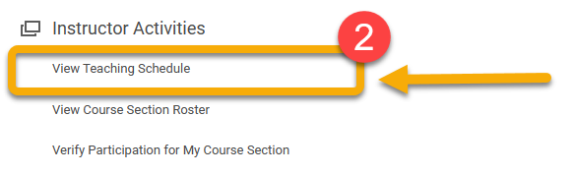

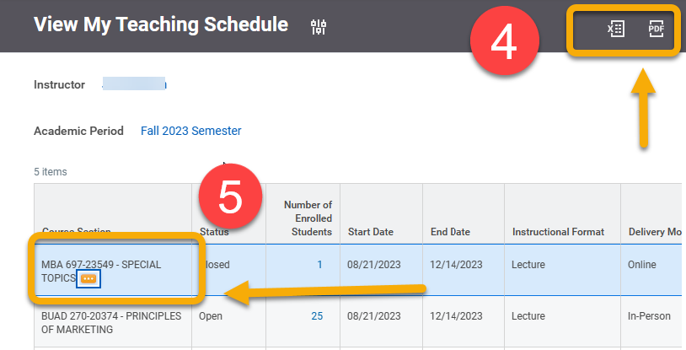
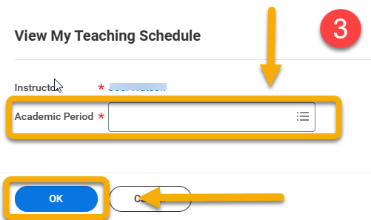

INSTRUCTIONS
- Log into Workday. Click “Teaching” from the top-left menu or the right-hand menu. This is the hub for all your instruction-related tasks.

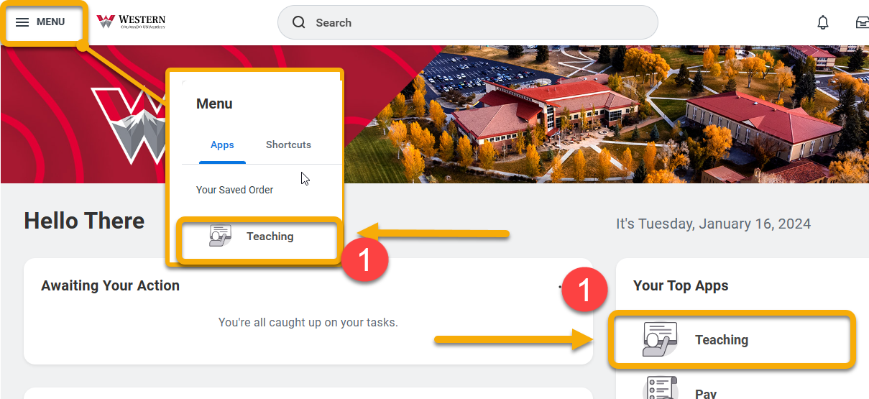

- Click “View Teaching Schedule”.
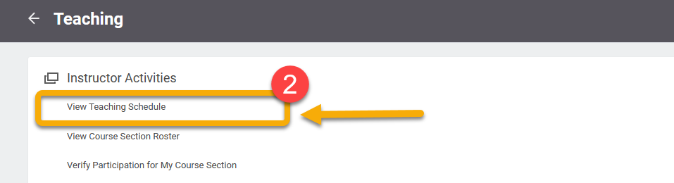

- Click the Academic Period field to open. Select the academic period or type it in.
Click “OK”.
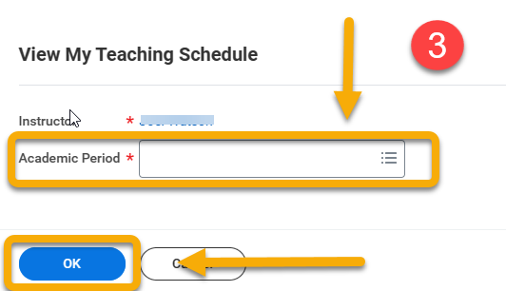
- View My Teaching Schedule displays your assigned course sections for the selected academic period.
From the top toolbar, you can A) Click the toggle button to select a different academic period, and B) export your teaching schedule into a printable format (as excel spreadsheet or PDF). Below is an example of the generated PDF.
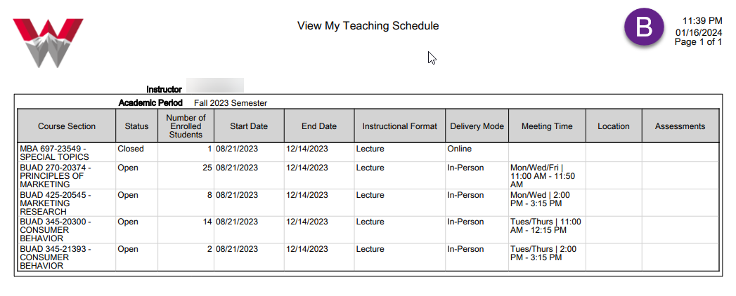
- Hover over a course section to reveal the Related Actions button This displays the option to view the enrollment and grade rosters.
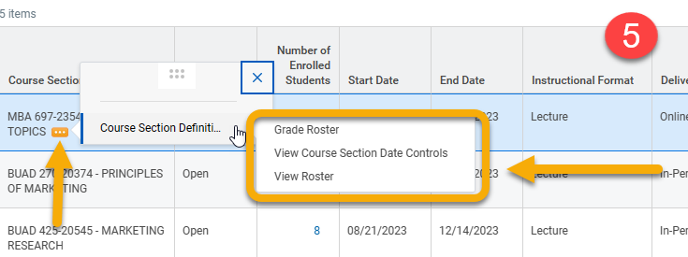
TIP: Right-click course section details and select “See in New Tab”. This will open the details in a new window allowing you to close the window when finished and quickly return to My Teaching Schedule.
- To print a complete roster with course section information, hover over a course section to reveal the Related Actions button
Hover over “Course Section Definition”.
Right-click “View Roster”. Select View Printable Version or Export to Excel. The document will automatically download to your computer. Below is an example
